Task: 1. Create 4 IAM users named “Dev1”, “Dev2”, “Test1”, and “Test2”.
2. Create 2 groups named “Dev Team” and “Ops Team”.
3. Add Dev1 and Dev2 to the Dev Team.
4. Add Dev1, Test1 and Test2 to the Ops Team.

Step 1: Login to AWS console > Search IAM > Inside IAM click on IAM users > Click on Create User.
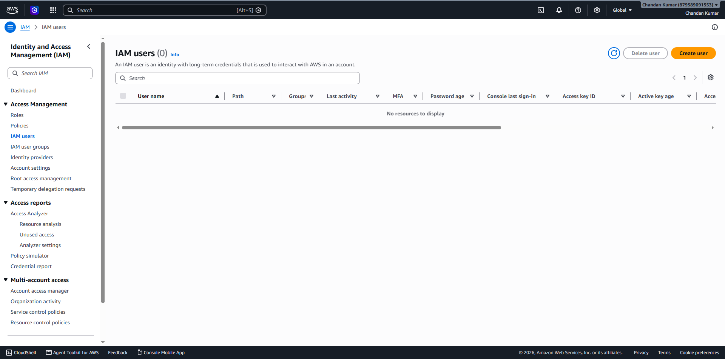
Step 2: Under User details > user name = Dev1 > Click on Next > Click on Next > Click on create user .
Click on Create User > Under User details > user name = Dev2 > Click on Next > Click on Next > Click on create user .
Click on Create User > Under User details > user name = Test1 > Click on Next > Click on Next > Click on create user .
Click on Create User > Under User details > user name = Test2 > Click on Next > Click on Next > Click on create user .
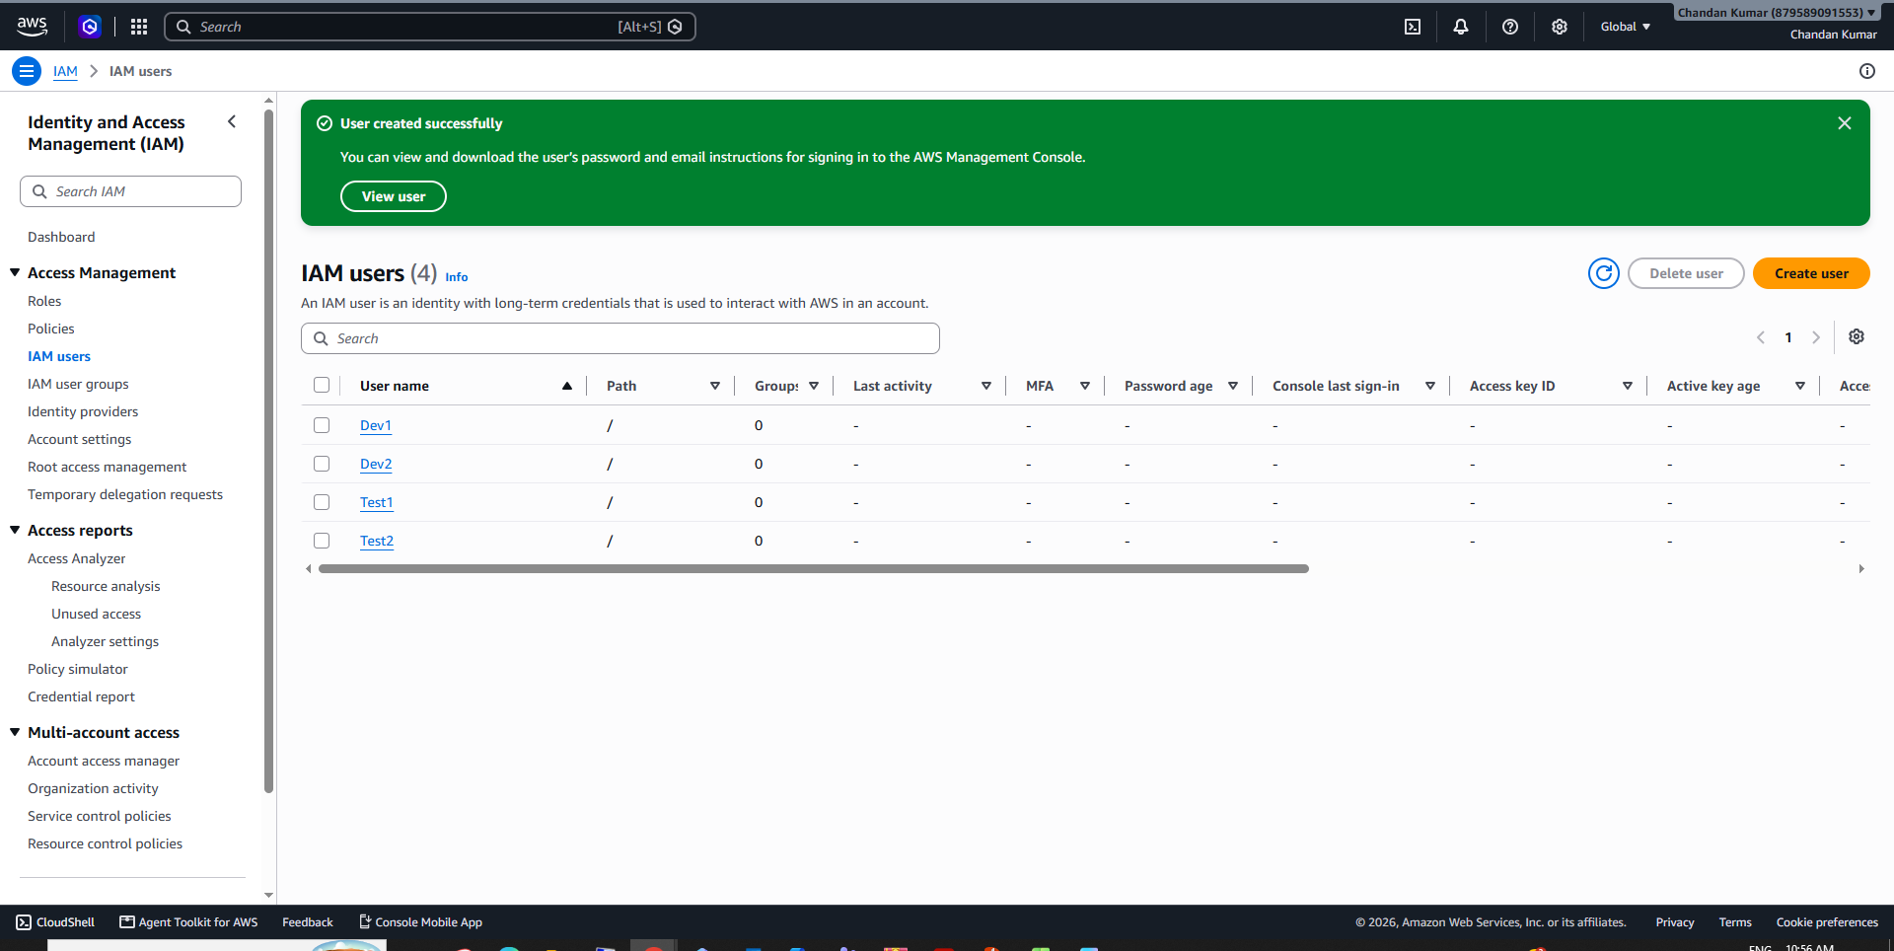
Step 3: Under Identity and Access Management (IAM) > Access Management > Click on IAM user groups > Click on create group.
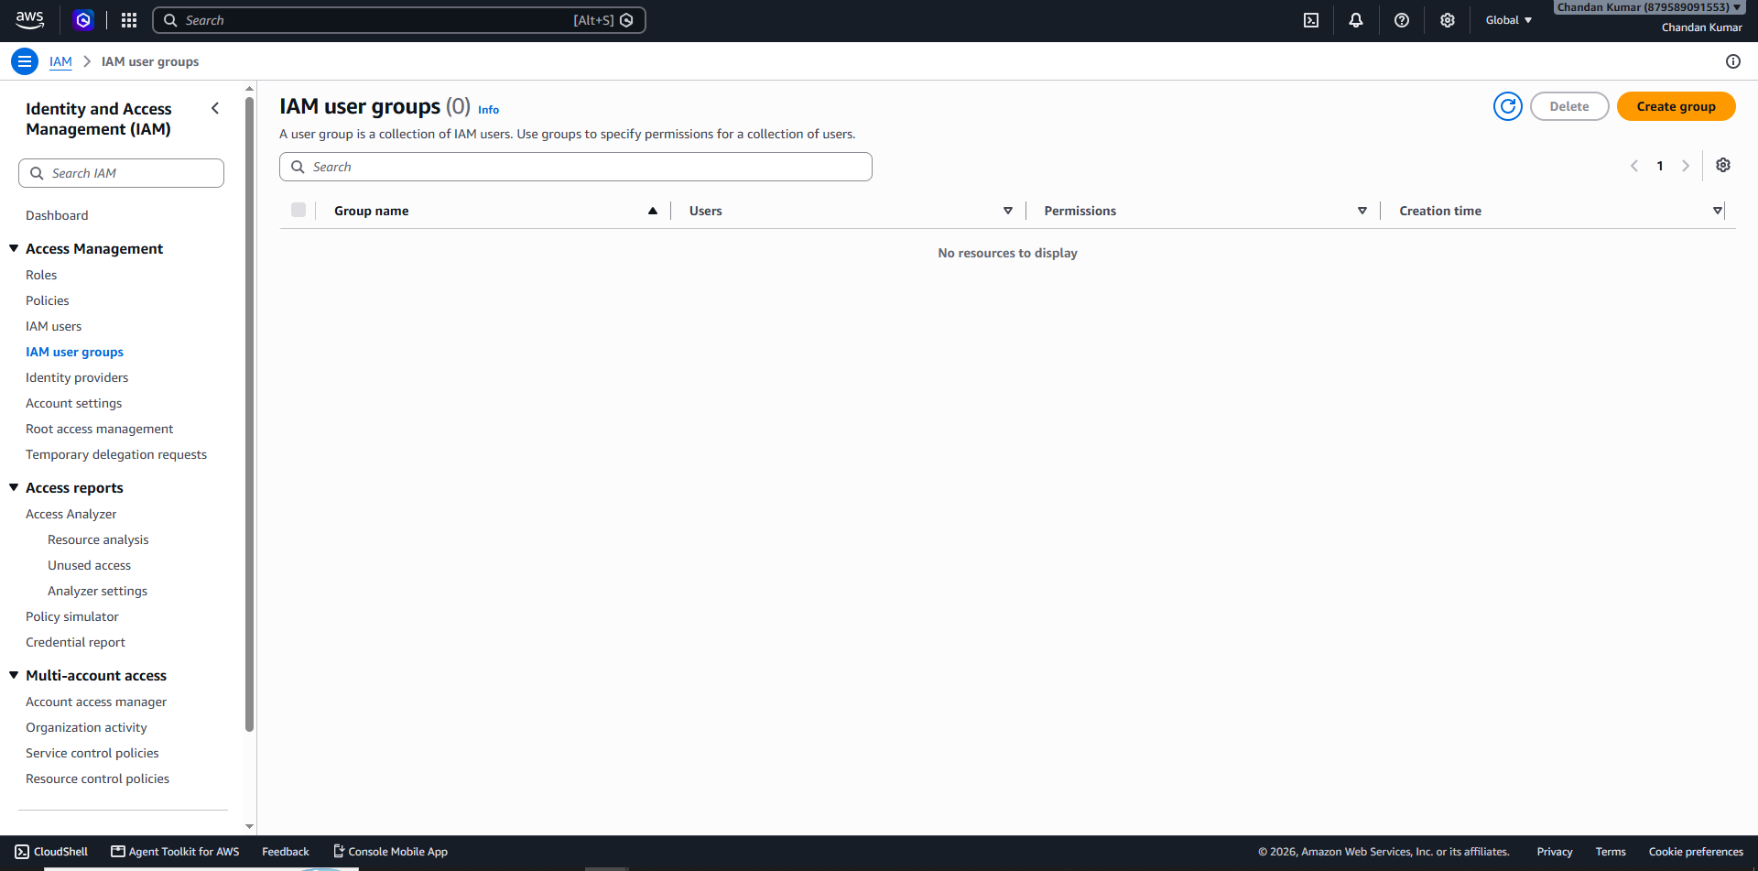
Step 4: User group name = DevTeam > Add users to the group = Dev1 and Dev2 > Click on create user group.
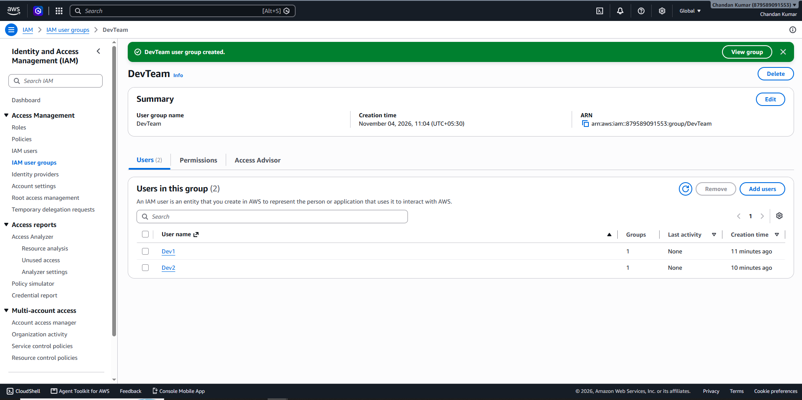
Step 5: Click on Create group > User group name = OpsTeam > Add users to the group = Dev1, Test1 and Test2 > Click on create user group.


